10000/10000 [==============================] - 13s 1ms/sample - loss: 0.1739 - acc: 0.1192

The testing accuracy metric for 0.001 learning rate is [0.1738808480501175, 0.1192]

---------------------------------------------------

10000/10000 [==============================] - 13s 1ms/sample - loss: 0.1759 - acc: 0.1114

The testing accuracy metric for 0.01 learning rate is [0.17590084850788115, 0.1114]

---------------------------------------------------

10000/10000 [==============================] - 34s 3ms/sample - loss: 0.1691 - acc: 0.1544

The testing accuracy metric for 0.1 learning rate is [0.16909292495250702, 0.1544]

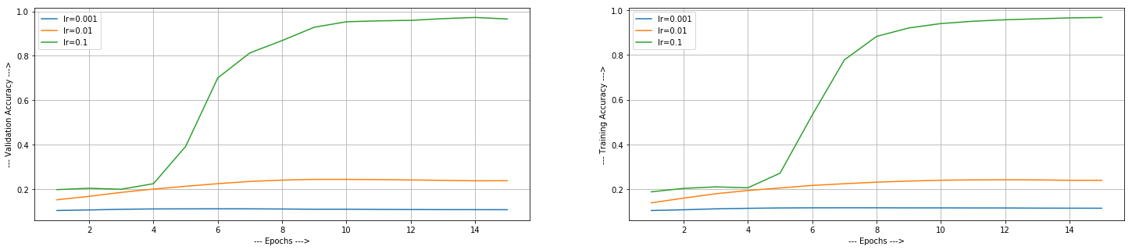

**Learning Rate vs Accuracy**:

1. N=0.01: When the learning rate was this small, it is taking time to gain some accuracy. That’s why we see that training and validation accuracy is quite low in this case as compared to N=0.1. Both training and validation accuracy only reached around 24% after 15 epoch.
2. N= 0.1: Being the greatest among all other, the model learned very quickly. We can also see that , the validation accuracy reached around 80% after six epoch only for lr=0.1, while the one with learning rate 0.01 is at 24% and the one with 0.001 is around 10%. But sometimes increasing learning rate beyond limit also creates problem. It shoots out of the optimal solution and accuracy starts decreasing.